System and Software Architecture Description (SSAD)

Los Angeles Child Guidance Clinic Employment
Opportunities Online Application System

Team 5

Hao Cai – Project Manager, builder
Chan Li – Life Cycle Planner
Hao Cai – Prototyper
Shipeng Xu – Software Architect
Zhen Huang – Operational Concept Engineer
Cresta Kirkwood – IIV&V
Cresta Kirkwood – Requirements Engineer
Ruixin Huang – Feasibility Analyst

April 26, 2012

Version History
Date | Author | Version | Changes made | Rationale
10/06/11 | SX | 1.0 | - All details known as of 10/06/11 | - Initial Draft
10/13/11 | SX | 1.1 | - Fixed the use case bugs | - Second Draft
10/15/11 | SX | 1.2 | - Redrew the diagrams with RSM | - Third Draft
10/16/11 | SX | 1.3 | - Add some use cases and fixed the requirement bugs. | - Fourth Draft
10/21/11 | SX | 2.0 | - Fixed the precondition problems | - Fifth Draft
11/20/11 | SX | 2.1 | - Finished the remaining sections | - Draft for DCP
11/29/11 | SX | 2.2 | - Fixed several bugs | - Revised version of Draft DCP
12/05/11 | SX | 2.3 | - Updated the SSAD status | - Final Product for DCP
02/03/12 | SX | 3.0 | - Changed the whole new design | - The draft for RDC ARB
02/15/12 | SX | 3.1 | - Made some changes to the rationales | - The product for RDC package
03/24/12 | SX | 3.2 | - Updated UML models and design | - The product for IOC Package
04/07/12 | SX | 3.3 | - Updated UML models and design | - Revised version of previous design
04/26/12 | SX | 3.4 | - Updated the design | - The product for TS SET package

Table of Contents
System and Software Architecture Description (SSAD) i
Version History ii
Table of Contents iii
Table of Tables iv
Table of Figures vii
1. Introduction 1
1.1 Purpose of the SSAD 1
1.2 Status of the SSAD 1
2. System Analysis 2
2.1 System Analysis Overview 2
2.2 System Analysis Rationale 23
3. Technology-Specific System Design 24
3.1 Design Overview 24
3.2 Design Rationale 38
4. Architectural Styles, Patterns and Frameworks 39

Table of Tables
Table 1: Actors Summary 3
Table 2: Artifacts and Information Summary 5
Table 3: Process Description – Create job postings 6
Table 4: Typical Course of Action – Create job postings 6
Table 5: Alternate Course of Action – Create job postings: Incomplete 6
Table 6: Process Description – Update job postings 7
Table 7: Typical Course of Action – Update job postings 7
Table 8: Alternate Course of Action – Update job postings 7
Table 9: Process Description – View job postings 8
Table 10: Typical Course of Action – View job postings 8
Table 11: Process Description – Submit a job application form 8
Table 12: Typical Course of Action – Submit a job application form 9
Table 13: Alternate Course of Action – Submit a job application form: Incomplete 9
Table 14: Process Description – Upload attachments 9
Table 15: Typical Course of Action – Upload attachments: Validate the formats 9
Table 16: Alternate Course of Action – Upload attachments: Invalid formats 10
Table 17: Process Description – Update an application form 10
Table 18: Typical Course of Action – Update an application form 10
Table 19: Alternate Course of Action – Update an application form: Incomplete 10
Table 20: Process Description – View application form 11
Table 21: Typical Course of Action – View application form 11
Table 22: Process Description – View applications 11
Table 23: Typical Course of Action – View applications 12
Table 24: Process Description – Login 12
Table 25: Typical Course of Action – Login: successful 12
Table 26: Alternate Course of Action – Login: failure 13
Table 27: Exceptional Course of Action– Login: Four consecutive login failures 13
Table 28: Process Description – Logout 13
Table 29: Typical Course of Action – Logout 13
Table 30: Exceptional Course of Action – Session timeout 14
Table 31: Process Description – Create personal profile 14
Table 32: Typical Course of Action – Create personal profile: Successful 14
Table 33: Alternate Course of Action – Create personal profile: Unsuccessful 14
Table 34: Process Description – update a profile 15
Table 35: Typical Course of Action – update a profile 15
Table 36: Process Description – View profile 15
Table 37: Typical Course of Action – View profile 15
Table 38: Process Description – Generate application report 16
Table 39: Typical Course of Action – Generate application report 16
Table 40: Process Description – View application report 16
Table 41: Typical Course of Action – View application report 17
Table 42: Process Description – Track applicants 17
Table 43: Typical Course of Action – Track applicants 17
Table 44: Process Description – Change category 18
Table 45: Typical Course of Action – Change category: Yes 18
Table 46: Alternate Course of Action – Change category: No 18
Table 47: Process Description – Change status of an applicant 19
Table 48: Typical Course of Action – Change status of an applicant: Successful 19
Table 49: Alternate Course of Action – Change status of an applicant: Unsuccessful 19
Table 50: Process Description – Create new user 20
Table 51: Typical Course of Action – Create new user - Valid 20
Table 52: Alternate Course of Action – Create new user - Invalid 20
Table 53: Process Description – Reset password 21
Table 54: Typical Course of Action – Reset password 21
Table 55: Process Description – Modify user roles 21
Table 56: Typical Course of Action – Modify user roles - Valid 21
Table 57: Process Description – View users 22
Table 58: Typical Course of Action – View users 22
Table 59: Hardware Component Description 26
Table 60: Software Component Description 27
Table 61: Design Class Description 28
Table 62: Design Class Description 30
Table 63: Design Class Description 31
Table 64: Design Class Description 32
Table 65: Design Class Description 33
Table 66: Architectural Styles, Patterns, and Frameworks 39

Table of Figures
Figure 1: System Context Diagram 3
Figure 2: Artifacts and Information Diagram 4
Figure 3: Process Diagram 5
Figure 4: Hardware Component Class Diagram 24
Figure 5: Software Component Class Diagram 25
Figure 6: Deployment Diagram 26
Figure 7: Main Class Diagram 28
Figure 8: Account Class Diagram 29
Figure 9: Application Diagram 30
Figure 10: ApplicationTracking Class Diagram 32
Figure 11: JobPosting Class Diagram 33
Figure 12: Deployment Diagram 34
Figure 13: Supporting Software Component Class Diagram 35
Figure 14: Design Class Diagram 35
Figure 15: Process Realization Diagram 36
Figure 16: Process Realization Diagram 36
Figure 17: Process Realization Diagram 37
Figure 18: Process Realization Diagram 38
Figure 19: Process Realization Diagram 38

Introduction

Purpose of the SSAD
The purpose of the SSAD is to document the results of the analysis and design of the Los Angeles Child Guidance Clinic Employment Opportunities Online Application System. The developers use the SSAD as a reference to the system’s architecture. Therefore, the system should be faithful to the architecture. The SSAD is also used by maintainers and clients to understand the structure and design of the system once the system is delivered.

Status of the SSAD
The current version of the SSAD is a part of the TS set package. The document provides an overview of the system, describes the system context, describes artifacts and information created by the system, and describes the behavior of the system. What’s more, this version of SSAD also includes all the class diagrams, hardware component diagrams, software component diagrams, and sequence diagrams. The design of the system is fully detailed in this version of SSAD.
Due to the change of mind from our clients at the end of last semester, our development language has been changed from JSP to PHP. This means that our online application system was designed over again. Now, our website has been restructured using PHP Symfony framework.

System Analysis

System Analysis Overview
The primary purpose of the Los Angeles Child Guidance Clinic Employment Opportunities Online Application System is to expedite the application process for job applicants and for the Clinic’s HR staff. This system will save time and be more attractive to job-seekers, facilitating the Clinic’s hiring process. The system will allow job candidates to fill out forms directly on the website, which can then be submitted electronically to the Clinic’s hiring department. Job listings will be sectioned off by department, with separate pages for each individual listing. The system will be easily edited by internal staff, as employment openings turn over too quickly to conveniently updated through a third party.

System Context
Figure 1 shows the operation context of the Los Angeles Child Guidance Clinic Employment Opportunities Online Application System.

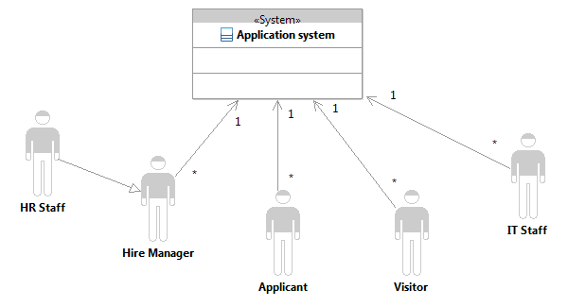
Figure 1: System Context Diagram

Table 1: Actors Summary describes the actors and their responsibilities related to the system.
Table 1: Actors Summary
Actor | Description | Responsibilities
HR Staff | HR Staff are the ones who manage the job postings and job applications. | - View, transfer, and manage the job applications.  - Process and save applicant’s information.  - Edit, update the job postings.
HR Supervisor | HR Supervisor serves as the power user for the system and has full access to the entire system. | - Manage application reports  - Edit, update the job postings.
IT Staff | IT staff serves as the system administrator and has full access to the entire system. | - Manage accounts for the system  - System maintenance.
Job applicant | Job applicant serves as the normal user of the system and has limited access to his own profile. | - Submit job application form  - Upload documents
Visitor | Visitors are the ones that browse the website. | - Visitors need to register if they want to apply for a job opening.
Hiring Manager | Hiring Manager is the one to determine qualified applicant. | - Change status for the qualified applicant.

Artifacts & Information

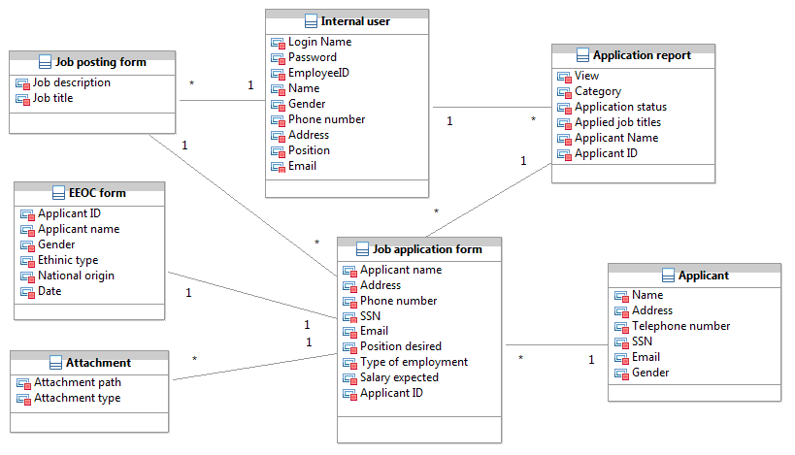

Figure 2: Artifacts and Information Diagram

Table 2 contains a description of each artifact shown in Figure 2.
Table 2: Artifacts and Information Summary
Artifact | Purpose
ATF-1: Job posting form | Contains job information by different titles and different departments, which will be viewed and referenced by the job applicants.
ATF-2: Job application form | Contains the application information for a job applicant.
ATF-3: EEOC form | Contains the ethnicity information of the applicant.
ATF-4: Applicant profile | Stores the applicant information like applicant id, type of applicant, contact information, etc.
ATF-5: Internal user profile | Stores the internal user information like employee id, employee name, email, etc.
ATF-6: Attachments | Contains the applicant’s personal documents.
ATF-7: Application reports | Contains information on application status reports by different categories, different job titles, and different time periods.

Behavior

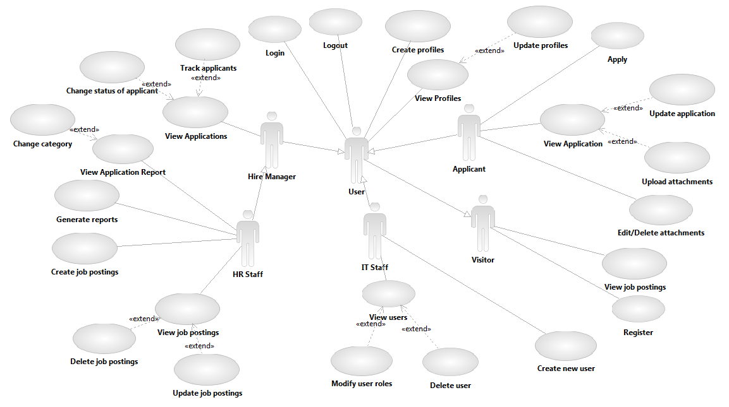

Figure 3: Process Diagram

2.1.3.1 Manage job postings

Create job postings
Table 3: Process Description – Create job postings
Identifier | UC-1: Create job postings
Purpose | Allow the HR staff to create job postings for the online system.
Requirements | CR-8 “Add a Job Post”
Development Risks | - None
Pre-conditions | - User is an HR staff or HR supervisor of the clinic  - User is logged into the system  - Database is initialized
Post-conditions | - Jobs information is available from the online system.

Table 4: Typical Course of Action – Create job postings
Seq# | Actor’s Action | System’s Response
1 | Login as HR staff
2 | Attempt to create a job posting
3 |  | Check webpage for completeness
4 |  | Display a message to indicate the job postings are updated
Table 5: Alternate Course of Action – Create job postings: Incomplete
Seq# | Actor’s Action | System’s Response
1 | Login as HR staff
2 | Attempt to create a new job posting
3 | Fail to finish the job postings
4 | Click “Save”
5 |  | Check webpage for completeness
6 |  | Reload the webpage and indicate which required information was not completed

Update job postings
Table 6: Process Description – Update job postings
Identifier | UC-2: Update job postings
Purpose | Allow the HR staff and HR supervisors to update the job postings for the online application system.
Requirements | CR-9 “Edit a Job Post”, CR10 “Remove an old post”
Development Risks | - None
Pre-conditions | - Job postings information is not up-to-date in the database.
Post-conditions | - Job postings are updated.  - New job information is stored in the database.

Table 7: Typical Course of Action – Update job postings
Seq# | Actor’s Action | System’s Response
1 | Log in as the HR staff
2 | Attempt to update the job posting
3 | Fill in all required fields
4 | Click “Edit”
5 |  | Check fields for completeness
6 |  | Display a message to indicate that the job postings are updated successfully
Table 8: Alternate Course of Action – Update job postings
Seq# | Actor’s Action | System’s Response
1 | Log in as the HR staff
2 | Attempt to update the job posting
3 | Fail to finish all required fields
4 | Click “Edit”
5 |  | Check fields for completeness
6 |  | Reload the form page and indicate which required fields were not completed

2.1.3.1.3 View Job Postings
Table 9: Process Description – View job postings
Identifier | UC-3: View application report
Purpose | Allow the HR staff and HR supervisors to view job postings
Requirements | CR-1 “Internal query and display”.
Development Risks | - None
Pre-conditions | - User is logged into the system as HR staff or as an HR supervisor.
Post-conditions | - Job postings of different categories or different titles are displayed to the HR staff.

Table 10: Typical Course of Action – View job postings
Seq# | Actor’s Action | System’s Response
1 | Click “Manage Job Postings”
2 | Choose “by department” or “by title”.
3 |  | Job posting is displayed to the HR Staff.

Application Process

Submit a job application form
Table 11: Process Description – Submit a job application form
Identifier | UC-4: Submit a job application form
Purpose | Allow an applicant to digitally submit a job application form so that applicants do not have to fax paper documents and the HR staff does not have to maintain the paper documents.
Requirements | CR-2 “Application attachments”, CR-5 “EEOC Generation”, CR-11 “One or more user applications”, CR-26 “Applicant partial privileges”, CR-27 “View Account”.
Development Risks | - None
Pre-conditions | - Applicant is logged into the system.  - Database is initialized
Post-conditions | - A job application form has been submitted.  - A job application form is stored in the database.

Table 12: Typical Course of Action – Submit a job application form
Seq# | Actor’s Action | System’s Response
1 | Fill in all required fields
2 | Click “Submit”
3 |  | Check form for completeness
4 |  | Display a message to indicate the form has been submitted
Table 13: Alternate Course of Action – Submit a job application form: Incomplete
Seq# | Actor’s Action | System’s Response
1 | Fail to finish all required fields
2 | Click “Submit”
3 |  | Check form for completeness
4 |  | Reload the form page and indicate which required fields were not completed

2.1.3.2.2 Upload attachments
Table 14: Process Description – Upload attachments
Identifier | UC-5: Upload Scanned Documents
Purpose | Allow applicants to upload scanned documents.
Requirements | CR-2 “Application attachments”
Development Risks | - None
Pre-conditions | - Applicant is logged into the system  - Applicant has access to upload a document
Post-conditions | - Uploaded documents are stored in the file system and path is stored in the database.

Table 15: Typical Course of Action – Upload attachments: Validate the formats
Seq# | Actor’s Action | System’s Response
1 | Fill in required fields.
2 | Select files to upload.
3 |  | Check the formats – valid formats.
4 |  | Store documents into the image server and store references into the database.
5 |  | Notify the applicant that the documents have been uploaded successfully.
Table 16: Alternate Course of Action – Upload attachments: Invalid formats
Seq# | Actor’s Action | System’s Response
1 | Fill in required fields.
2 | Select files to upload.
3 |  | Check the formats – invalid formats.
4 |  | Notify the applicant that the documents have invalid file formats.
5 |  | Redirect the applicant to the upload page.

2.1.3.2.3 Update application form
Table 17: Process Description – Update an application form
Identifier | UC-6: Update an application form
Purpose | Allow applicants to update their application form.
Requirements | CR-2 “Applicant attachments”, CR-26 “Applicant partial privileges”, CR-27 “View Account”, CR-41 “Prevent single person/Multiple user accounts using email addresses”.
Development Risks | - None
Pre-conditions | - Applicant is logged into the system  - Applicant has access to update the application form
Post-conditions | - Updated application form is stored in the database

Table 18: Typical Course of Action – Update an application form
Seq# | Actor’s Action | System’s Response
1 | Fill in all required fields
2 | Click “Edit”
3 |  | Check form for completeness
4 |  | Display a message to indicate the form has been updated successfully.
Table 19: Alternate Course of Action – Update an application form: Incomplete
Seq# | Actor’s Action | System’s Response
1 | Fail to finish all required fields
2 | Click “Edit”
3 |  | Check form for completeness
4 |  | Reload the form page and indicate which required fields were not completed.

2.1.3.2.4 View application form
Table 20: Process Description – View application form
Identifier | UC-7: View application form
Purpose | Allow the applicants to view their application forms
Requirements | CR-26 “Applicant Privileges”, CR-27 “View Account”.
Development Risks | - None
Pre-conditions | - User is logged into the system as an applicant.
Post-conditions | - Application form information is displayed to the applicant.

Table 21: Typical Course of Action – View application form
Seq# | Actor’s Action | System’s Response
1 | Click “View your applications”
2 | Click “Edit” link
3 |  | The application form is displayed to the applicant.

2.1.3.2.5 View applications
Table 22: Process Description – View applications
Identifier | UC-8: View applications
Purpose | Allow the HR staff and HR supervisors to view applications
Requirements | CR-15 “View applicant application”, CR-16 “Download applicant application”.
Development Risks | - None
Pre-conditions | - User is logged into the system as HR staff or as an HR supervisor.
Post-conditions | - Applications of different categories or different titles or different time periods are displayed to the HR staff.

Table 23: Typical Course of Action – View applications
Seq# | Actor’s Action | System’s Response
1 | Click “View your applications” link
2 | Choose “by department” or “by title” or “by time periods”.
3 |  | The applications are displayed to the HR Staff.

Authentication

2.1.3.3.1 Login
Table 24: Process Description – Login
Identifier | UC-9: Login
Purpose | Authorize a user to log into the system and determine the user’s role and access privileges.
Requirements | CR-12 “Applicant/HR/IT login”
Development Risks | - None
Pre-conditions | - System database is properly initialized
Post-conditions | - If the user’s login successfully, the user is able to access system with the access privileges of the user’s role  - If the user’s log in information is not valid, the system informs the user that she/he has entered an invalid username and password

Table 25: Typical Course of Action – Login: successful
Seq# | Actor’s Action | System’s Response
1 | Enter a username and password
2 | Click the “Login” button
3 |  | Validate username and password
4 |  | Redirect the user to their personal home page.
Table 26: Alternate Course of Action – Login: failure
Seq# | Actor’s Action | System’s Response
1 | Enter a username and password
2 | Click the “Login” button
3 |  | Validate username and password
4 |  | Redirect the user to the login page and informs the user that he/she has entered an invalid username or password.
Table 27: Exceptional Course of Action– Login: Four consecutive login failures
Seq# | Actor’s Action | System’s Response
1 | Unsuccessfully attempt to log in to the system four consecutive times
2 |  | Disable the user’s privilege to login.
3 |  | Notify the user that he/she will have to contact the administrator.

Logout
Table 28: Process Description – Logout
Identifier | UC-10: Logout
Purpose | Enable a user to logout
Requirements | CR-14 “Applicant/HR/IT logout”.
Development Risks | - None
Pre-conditions | - The user is logged in  - The user’s session exists
Post-conditions | - The user is logged out and the session is terminated

Table 29: Typical Course of Action – Logout
Seq# | Actor’s Action | System’s Response
1 | Click the “log out” button.
2 |  | Log the user out and terminate the session.
3 |  | Notify the user that he/she has logged out of the system.

Table 30: Exceptional Course of Action – Session timeout
Seq# | Actor’s Action | System’s Response
1 | If the user doesn’t stay active on the webpage for 10 minutes.
2 |  | Automatically logout the user and terminate the session.
3 |  | Notify the user that the session was expired and that he was logged out.

Manage profiles

2.1.3.4.1 Create personal profile
Table 31: Process Description – Create personal profile
Identifier | UC-11: Create personal profile
Purpose | Allow a system user to create a personal profile.
Requirements | CR-13 “Distinct Applicant/HR/IT roles”, CR-20 “External account creation”.
Development Risks | - None
Pre-conditions | - User’s personal profile is not created in the system
Post-conditions | - A personal profile is created for the system user

Table 32: Typical Course of Action – Create personal profile: Successful
Seq# | Actor’s Action | System’s Response
1 | Select “Create profile” and enter all the required fields.
2 |  | Validate that if the user has filled all the required fields.
3 |  | Add the user profile to the system.
Table 33: Alternate Course of Action – Create personal profile: Unsuccessful
Seq# | Actor’s Action | System’s Response
1 | Select “Create profile” and enter all the required fields.
2 |  | Validate that if the user has filled all the required fields.
3 |  | Notify the user that he needs to finish all the required fields.

Update a profile
Table 34: Process Description – update a profile
Identifier | UC-12: update a profile
Purpose | Enable users to edit their personal profiles.
Requirements | CR-26 “Applicant partial privileges”, CR-27 “View Account”.
Development Risks | - None
Pre-conditions | - User logs into the system  - User has a profile in the system
Post-conditions | - User updated his/her profile successfully

Table 35: Typical Course of Action – update a profile
Seq# | Actor’s Action | System’s Response
1 | Click “Profile”.
2 |  | Display the profile information.
3 | Click “Edit”.
4 |  | Edit the profile information.

2.1.3.4.3 View profile
Table 36: Process Description – View profile
Identifier | UC-13: View profile
Purpose | Allow the system users to view their profiles
Requirements | CR-26 “Applicant Privileges”, CR-27 “View Account”.
Development Risks | - None
Pre-conditions | - User is logged into the system.
Post-conditions | - User profile is displayed to the user.

Table 37: Typical Course of Action – View profile
Seq# | Actor’s Action | System’s Response
1 | Click “View Profile”
2 | Choose “by department” or “by title” or “by time periods”.
3 |  | The user profile is displayed to the user.

      - Generate reports

2.1.3.5.1 Generate application report
Table 38: Process Description – Generate application report
Identifier | UC-14: Generate employment status report
Purpose | Allow the HR staff and HR supervisors to generate an application report
Requirements | CR-4 “System reports”, CR-7 “Applicant/Employment Category”.
Development Risks | - None
Pre-conditions | - User is logged into the system as HR staff or as an HR supervisor.
Post-conditions | - Application reports of different categories or different titles or different time periods are stored in the system.

Table 39: Typical Course of Action – Generate application report
Seq# | Actor’s Action | System’s Response
1 | Click “Generate a Report”
2 | Choose “by department” or “by title” or “by time periods”.
3 |  | Generate an application report.
4 |  | Store the application report in database.

2.1.3.5.2 View application report
Table 40: Process Description – View application report
Identifier | UC-15: View application report
Purpose | Allow the HR staff and HR supervisors to view an application report
Requirements | CR-4 “System reports”, CR-6 “Application/Position Status”.
Development Risks | - None
Pre-conditions | - User is logged into the system as HR staff or as an HR supervisor.  - Application report is generated.
Post-conditions | - Application reports of different categories or different titles or different time periods are displayed to the HR staff.

Table 41: Typical Course of Action – View application report
Seq# | Actor’s Action | System’s Response
1 | Click “Track”
2 | Choose “by department” or “by title” or “by time periods”.
3 |  | An application report is displayed to the HR Staff.

      - Manage application status

2.1.3.6.1 Track applicants
Table 42: Process Description – Track applicants
Identifier | UC-16: Track applicants
Purpose | Allow power users to search for specific applicant and track the applicant’s application status.
Requirements | CR-1 “Internal query and display”, CR-6 “Application/Position status”, CR-7 “Applicant/Employment Category”, CR-15 “View applicant application”, CR-16 “Download applicant application”, CR-17 “search user profiles”
Development Risks | - None
Pre-conditions | - HR Staff or HR supervisor logs into the system  - Database is initialized
Post-conditions | - System displays a list of applicants meeting the search criteria.

Table 43: Typical Course of Action – Track applicants
Seq# | Actor’s Action | System’s Response
1 | Fill in search field.
2 |  | Search within the system using the given parameters.
3 |  | Display a list of search results that the user can view.

Change category
Table 44: Process Description – Change category
Identifier | UC-17: Change category
Purpose | Enable HR staff to change the applicant’s category to either “qualified” or “unqualified”.
Requirements | CR-13 “Distinct Applicant/HR/IT Roles”.
Development Risks | - None
Pre-conditions | - HR staff logs into the system
Post-conditions | - Applicant’s category is changed to “qualified” or “unqualified”.

Table 45: Typical Course of Action – Change category: Yes
Seq# | Actor’s Action | System’s Response
1 | Select the applicant.
2 | Click on “View”
3 | Click “Change category”
4 |  | Display a message saying that the applicant’s category will be changed and ask the user to confirm.
5 | Select – “Yes”
6 |  | Change the applicant’s category.

Table 46: Alternate Course of Action – Change category: No
Seq# | Actor’s Action | System’s Response
1 | Select the applicant.
2 | Click on “View”
3 | Select “Change category”
4 |  | Display a message saying that the applicant’s category will be changed and ask the user to confirm.
5 | Select – “No”
6 |  | Redirect the user to the “Options” page.

2.1.3.6.3 Change status of an applicant
Table 47: Process Description – Change status of an applicant
Identifier | UC-18: Change status of an applicant
Purpose | Allow HR staff to change the status of applicants.
Requirements | CR-6 “Application/Position status”
Development Risks | - None
Pre-conditions | - The status of applicants were not updated in the database
Post-conditions | - The status of applicants is updated in the database.

Table 48: Typical Course of Action – Change status of an applicant: Successful
Seq# | Actor’s Action | System’s Response
1 | Select the status in the dropdown list and click “Save changes”.
2 |  | Validate that if the HR staff has made the change successfully.
3 |  | Update the applicant’s status in the system database.
Table 49: Alternate Course of Action – Change status of an applicant: Unsuccessful
Seq# | Actor’s Action | System’s Response
1 | Select the status in the dropdown list and click “Save changes”.
2 |  | Validate that if the HR staff has made the change successfully.
3 |  | Notify the HR staff that he needs to make the change.

Manage account

2.1.3.7.1 Create new user
Table 50: Process Description – Create new user
Identifier | UC-19: Create new user
Purpose | IT staff will be able to add new user to the system.
Requirements | CR-19 “Internal account creation”, CR-20 “External account creation”
Development Risks | - None
Pre-conditions | - IT staff logs into the system as an administrator.  - Database is initialized
Post-conditions | - New user added to the system.

Table 51: Typical Course of Action – Create new user - Valid
Seq# | Actor’s Action | System’s Response
1 | Fill in all required fields
2 | Click “Create new user”
3 |  | Validate all fields that have been entered.
4 |  | Create a new user.
5 |  | Send email notification to the new user that his user account has been created.
Table 52: Alternate Course of Action – Create new user - Invalid
Seq# | Actor’s Action | System’s Response
1 | Didn’t finish all required fields or enter invalid inputs.
2 | Click “Create new user”
3 |  | Validate all fields that have been entered.
4 |  | Reload the page and indicate which required fields were not completed or invalid.

Reset password
Table 53: Process Description – Reset password
Identifier | UC-20: Reset a user account password
Purpose | IT staff will be able to reset a user’s password when the user forgets his password.
Requirements | CR-21 “Reset password”, CR-22 “Recover password”.
Development Risks | - None
Pre-conditions | - IT staff logs into the system as an administrator  - Database is initialized
Post-conditions | - User’s password is reset  - User can log in successfully

Table 54: Typical Course of Action – Reset password
Seq# | Actor’s Action | System’s Response
1 | Select the user
2 | Choose “Options”
3 | Click on “Reset password”
4 |  | Reset the user’s password
5 |  | Allow the user to log into the system
6 |  | Send email notification that the user’s password has been reset.

Modify User Roles
Table 55: Process Description – Modify user roles
Identifier | UC-21: Modify user roles
Purpose | IT staff is able to modify user roles.
Requirements | CR-25 “Modify user roles”, CR-18 “Delete a user profile”.
Development Risks | - None
Pre-conditions | - IT staff logs into the system as an administrator
Post-conditions | - Selected user’s role is modified and saved in the database.

Table 56: Typical Course of Action – Modify user roles - Valid
Seq# | Actor’s Action | System’s Response
1 | Select the user
2 | Choose “Option”
3 | Click on “Change role”
4 | Choose the new role
5 |  | System modifies the specified user’s roles.
6 |  | System notifies the administrator the user’s role has been updated.

2.1.3.5.2 View users
Table 57: Process Description – View users
Identifier | UC-22: View users
Purpose | Allow the IT staff to view users.
Requirements | CR-13 “Distinct Applicant/HR/IT Roles.
Development Risks | - None
Pre-conditions | - User is logged into the system as an IT staff.
Post-conditions | - System users are displayed to the IT staff.

Table 58: Typical Course of Action – View users
Seq# | Actor’s Action | System’s Response
1 | Click “View Users”
2 |  | The system users are displayed to the IT staff.

Modes of Operation
The LA Child Guidance Clinic Employment Opportunities Online Application System only operates in one mode.

System Analysis Rationale

2.2.1 System business workflow
1. A potential applicant views the job postings through the online system.
2. The potential applicant registers for a user account.
3. The applicant starts the application process by filling and submitting the application form and EEOC form.
4. HR staff sees and screens the job applicants for the hiring managers.
5. Hiring managers view the qualified applicants for their corresponding departments and decide whom to interview with.
6. After interview with the applicants, the hiring manager could change the status of the applicants to either “Accepted” or “Declined”.
7. HR staff receives the list of applicants for further background checking.
8. HR staff informs the HR supervisor of who the real accepted applicants are.

2.2.2 System privileges of different roles in the system
1. Visitors can only view the job listings.
2. Applicants have access to their own profiles and job posting information in the system.
3. HR staff has the full access to view and update the job postings, view and change the status of the applicants, view and change the category of the applicants, and generates application reports.
4. HR supervisors have the same system privileges as the HR staff.
5. Hiring managers have limited access to the system. They can view and change the status of the applicants.
5. IT staff has the right to manage user accounts and reset passwords.

Technology-Specific System Design

Design Overview

System Structure
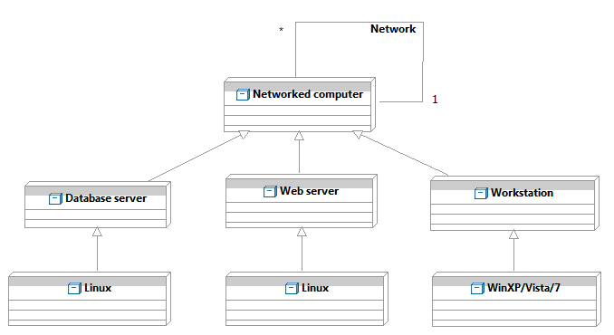Figure 4: Hardware Component Class Diagram
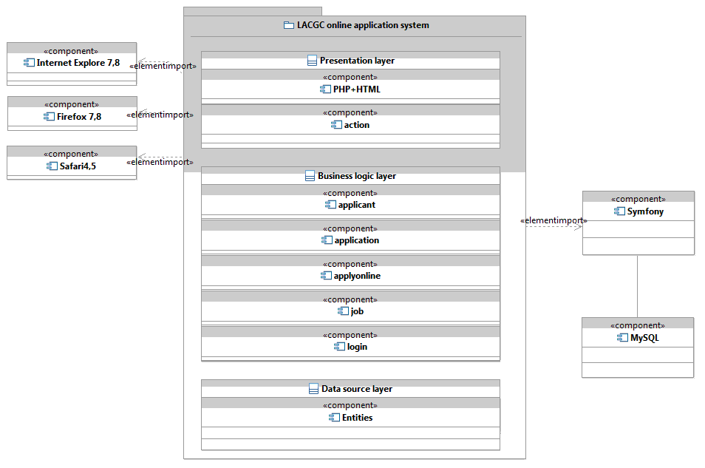Figure 5: Software Component Class Diagram
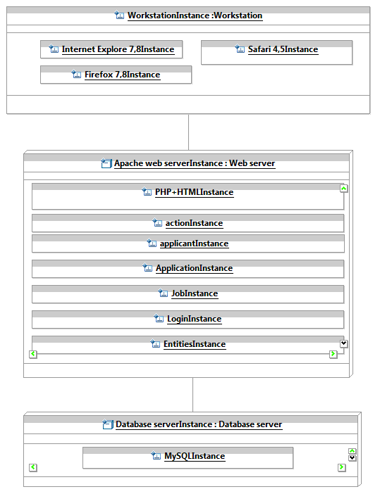
Figure 6: Deployment Diagram
Table 59: Hardware Component Description
Hardware Component | Description
Workstation | The workstation is the user’s machine in which the user uses browsers to connect to the system trough internet.
Web server | Web server is the hardware component where the system resides.
Database server | A specialized hardware component where the MySQL server runs on.

Table 60: Software Component Description
Software Component | Description
Presentation layer | This layer includes GUI components, action. GUI is the software component for web pages interface. Action component is the controller for mapping inputs into operations.
Business logic layer | This layer contains all logic components.  Application component provides functionalities for applicants to use the system to sign up, apply, upload attachments, and edit profiles.  Job posting component provides functionalities for HR staff to manage job postings which includes “post job”, “delete job”, and “edit job”.  Track application component provides functionalities for employee to manage applications including change status, change category, track applicants and export reports.  User component provides functionalities for managing all user accounts including create, edit, and delete accounts and login, logout the system.
Data source layer | This layer includes all components to interact with the database. Entity component represents the entity classes which are mapped into the database tables. Doctrine component contains all the operating classes accounting for all the database operations.

Design Classes

Main Class Diagram
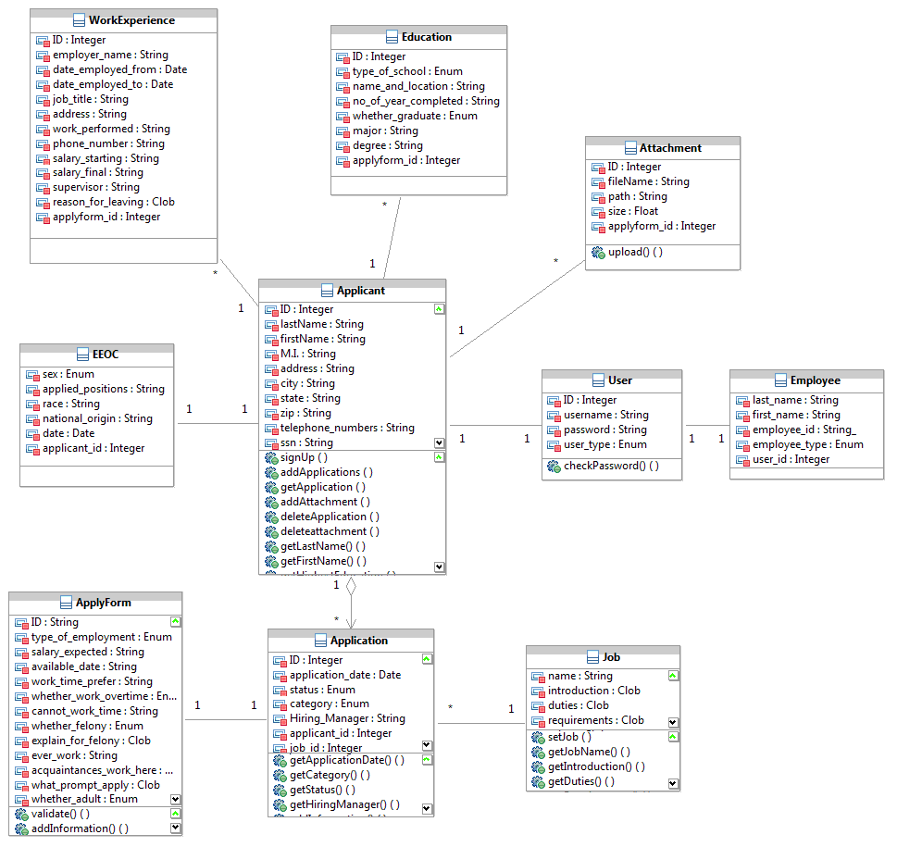
Figure 7: Main Class Diagram
Table 61: Design Class Description
Class | Type | Description
Applicant | Entity | Encapsulate applicant’s profile and operations, and then map applicant’s attributes into the database.
Application | Entity | Encapsulate applicant’s application fields and operations, and then map them into the database.
EEOC | Entity | Encapsulate fields and operations of “Equal Employment Opportunity Commission”, and map it into the database.
ApplyForm | Entity | Encapsulate fields and operations of the application forms, and then map them into the database.
Education | Entity | Encapsulate fields of applicant’s education information, and then map them into the database.
WorkExperience | Entity | Contains fields of applicant’s work experience information, and then map them into the database.
Attachment | Entity | Contains the applicant’s attachment’s information, and then map them into the database.
User | Entity | Encapsulate the entire system user’s login information, and map it into the database.
Employee | Entity | Encapsulate employee’s profile and operations, and then map employee’s attributes into the database.
Job | Entity | Encapsulate job fields and operations, and map them into the database.

User Class Diagram
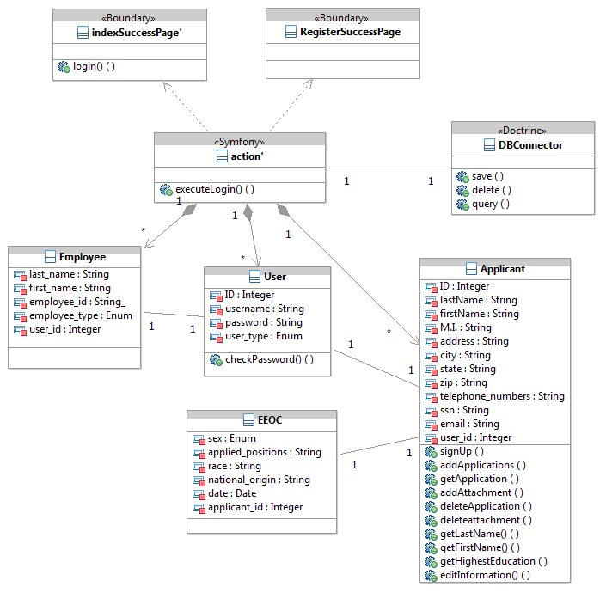
Figure 8: User Class Diagram
Table 62: Design Class Description
Class | Type | Description
indexSuccessPage, RegisterSuccessPage | PHP Boundary | Web GUI.
Action’ | Symfony | Validates inputs from the GUI webpages and calls on corresponding services and functions.
DBconnector | Doctrine | Interface of Doctrine for manipulating database.

Application Class Diagram
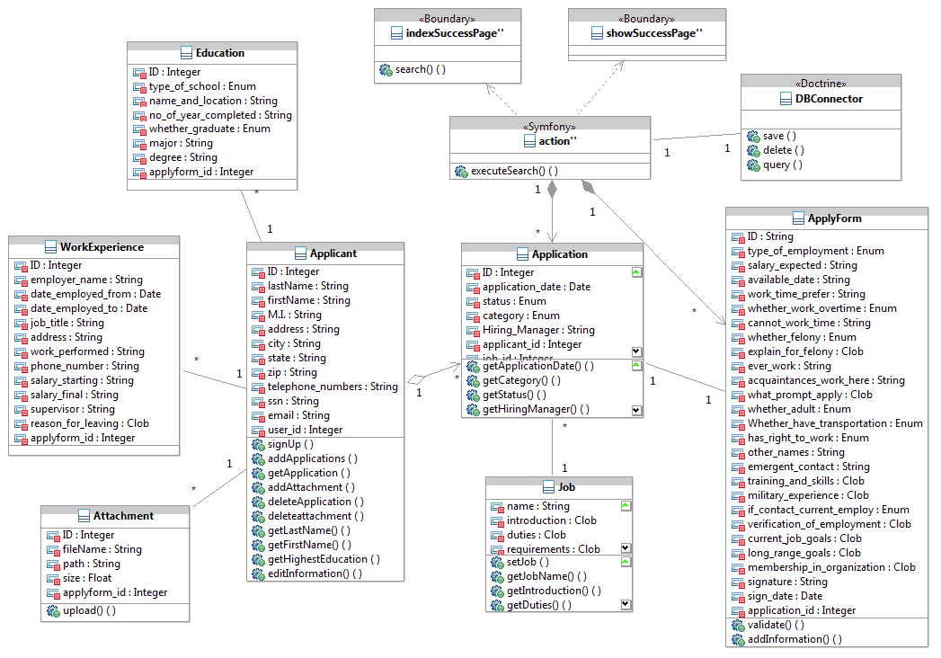Figure 9: Application Class Diagram
Table 63: Design Class Description
Class | Type | Description
indexSuccessPage, showSuccessPage | Boundary | Web GUI.
Action’’ | Symfony | Validate inputs from the GUI webpages and call on corresponding functions.

Apply Class Diagram
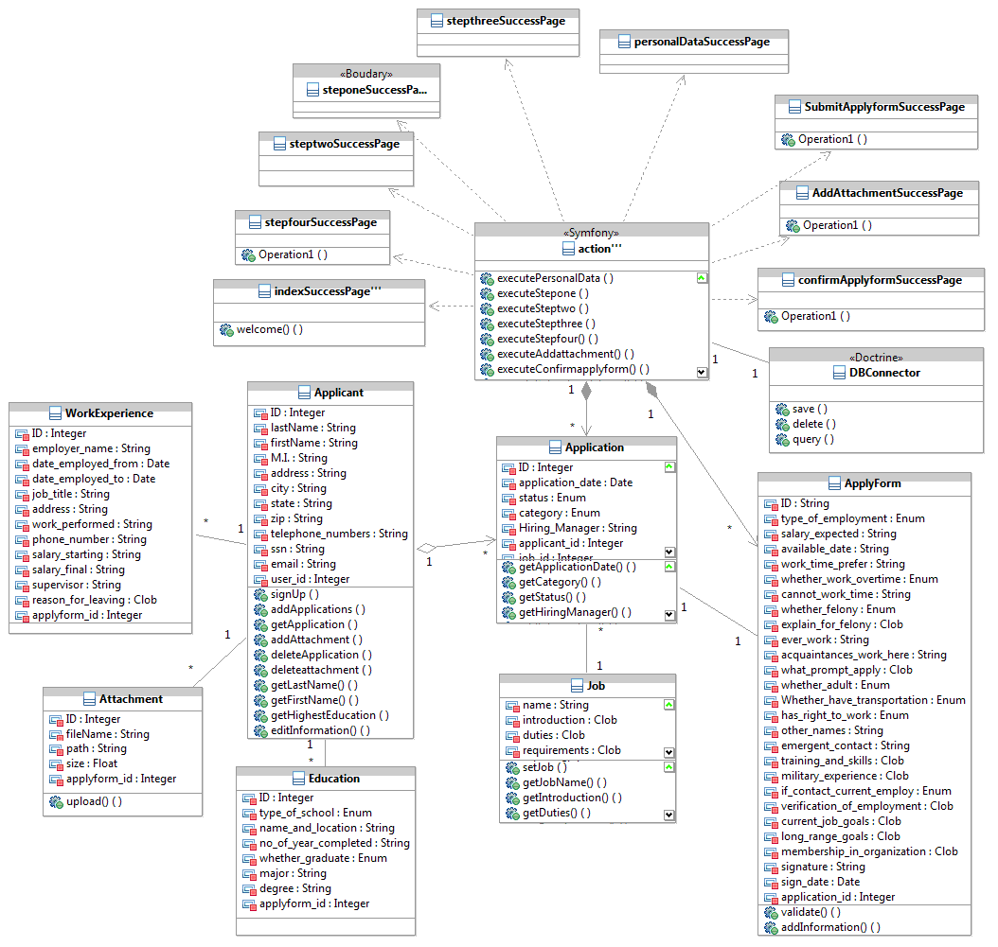
Figure 10: Apply Class Diagram

Table 64: Design Class Description
Class | Type | Description
indexSuccessPage, confirmApplyFormSuccessPage,  stepOneSuccessPage…… | PHP Boundary | Web GUI.
Action’’’ | Symfony | Encapsulate form fields submitted by the corresponding boundary web pages, validate inputs and call on corresponding functions.

Job Posting Class Diagram

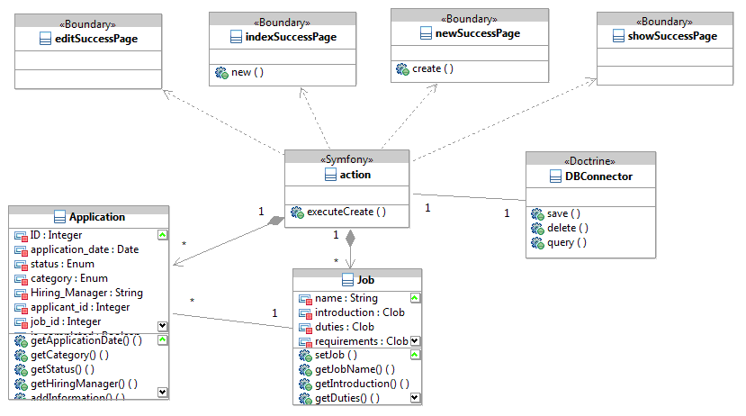
Figure 11: Job Posting Class Diagram

Table 65: Design Class Description
Class | Type | Description
editSuccessPage, indexSuccessPage, newSuccessPage,  showSuccessPage | Boundary | Web GUI.
action | Symfony | Encapsulate form fields submitted by the corresponding boundary web pages, validate inputs and call on corresponding services.

Process Realization
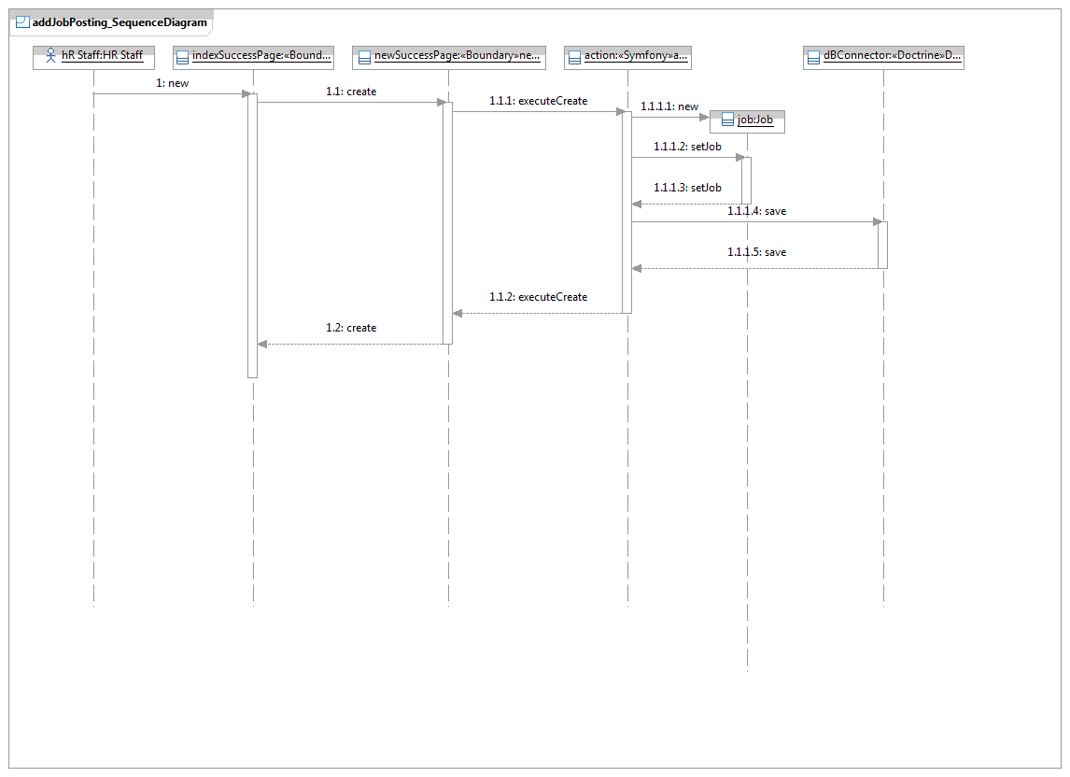
Figure 12: Process Realization Diagram
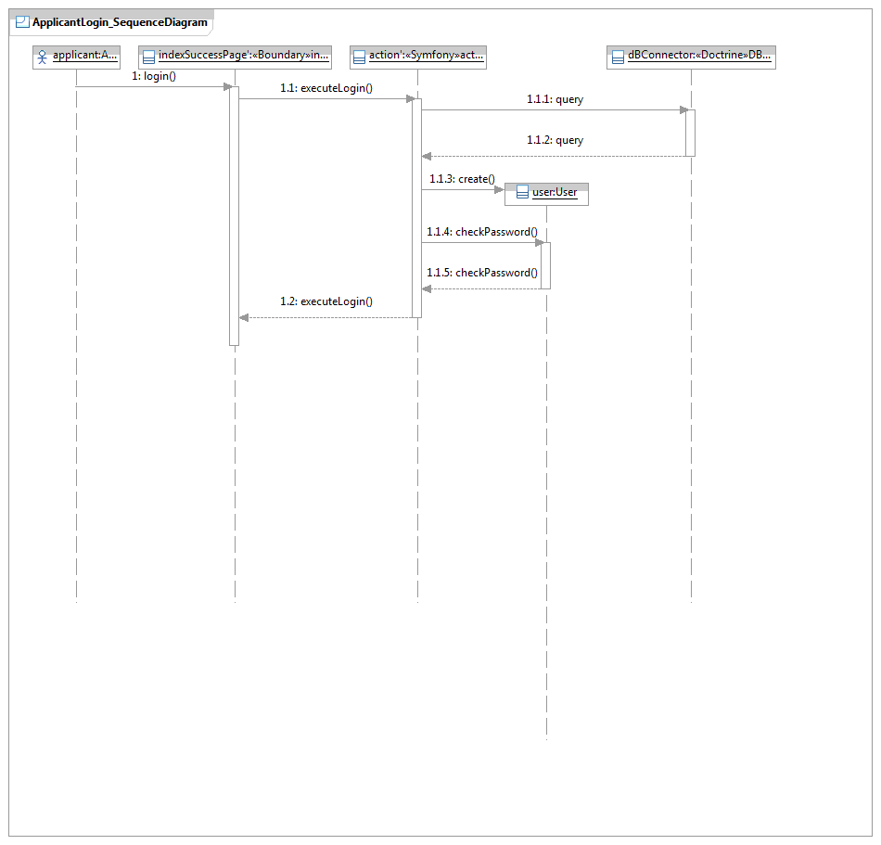
Figure 13: Process Realization Diagram
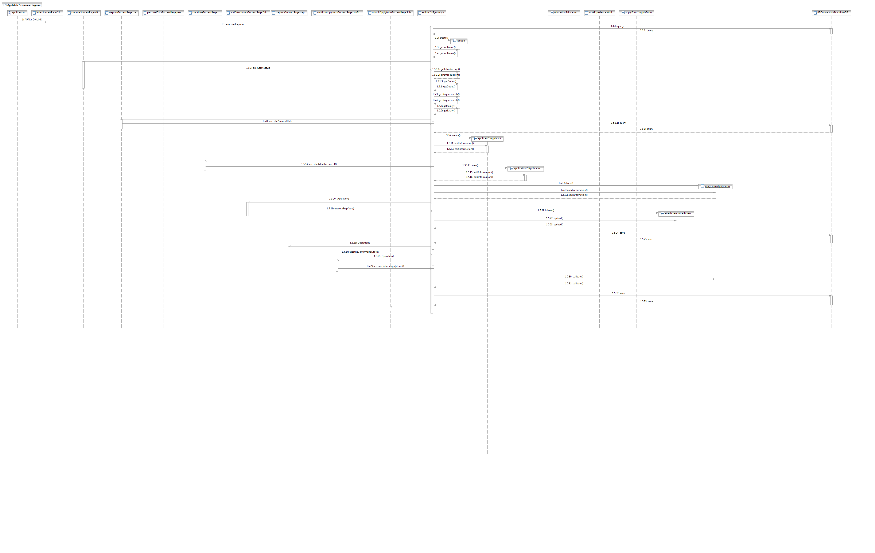
Figure 14: Process Realization Diagram
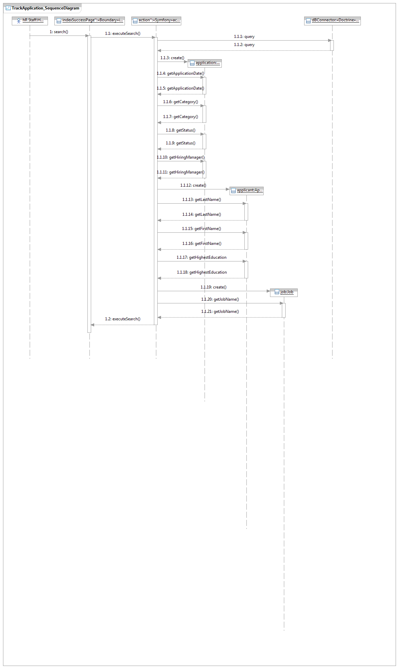
Figure 15: Process Realization Diagram

Design Rationale
Our project architecture design is based on PHP MVC Framework of Symfony.

Model---includes all the components of business logic and database manipulation. Business logic consists of job posting component, applicant component, application component, and login component. Database manipulation includes entity classes.

View---All the boundary web pages are designed in order to serve as Views in MVC Framework.

Controller---contains actions which validate inputs and map inputs into operations and return process results.

Architectural Styles, Patterns and Frameworks
Table 66: Architectural Styles, Patterns, and Frameworks
Name | Description | Benefits, Costs, and Limitations
Symfony MVC Framework | Symfony is an open source framework for building PHP web applications using Model View Controller (MVC) design pattern. | Symfony provide the basic infrastructure for implementing MVC allowing developers to concentrate on the business logic. Symfony also provides the doctrine to map database tables into objects. The framework is also flexible and can be extended to meet the requirements specific to a project.

IOC
IOC
Presentation layer
Symfony pages
Business layer
Symfony action classes
Data source layer
Doctrine

Domain Model Business Objects

